**Mild to Moderate evaluation**

Sample_ID: **TCJTRA (Dog)**

Link**: https://release.animalbiome.com/pet/assessment/report/3108d133-5156-4f1f-a20e-e2a75e7a3a78**

Cats and dogs:

Any Two

(High Yellow Flag Megamonas OR (failed)

High Yellow Flag Sutterella OR (**passed**)

High Yellow Flag Collinsella OR (failed)

Low Yellow Flag Bacteroides OR (**passed**)

Low Yellow Flag Blautia (**passed**)

)

OR

OR Dogs: 4-7 Yellow Flags (**passed**)

OR 5-7 Red Flags; (**passed**)

OR diet recommendation of increase fibre (**passed**)

OR diet recommendation of increase protein (**passed**)

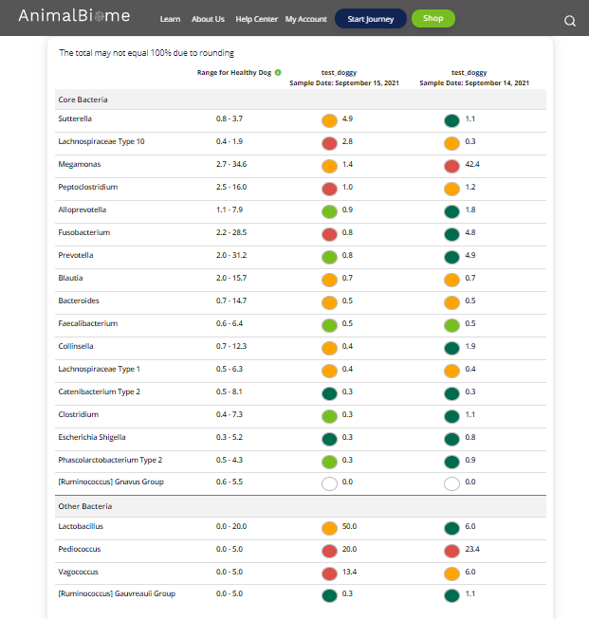

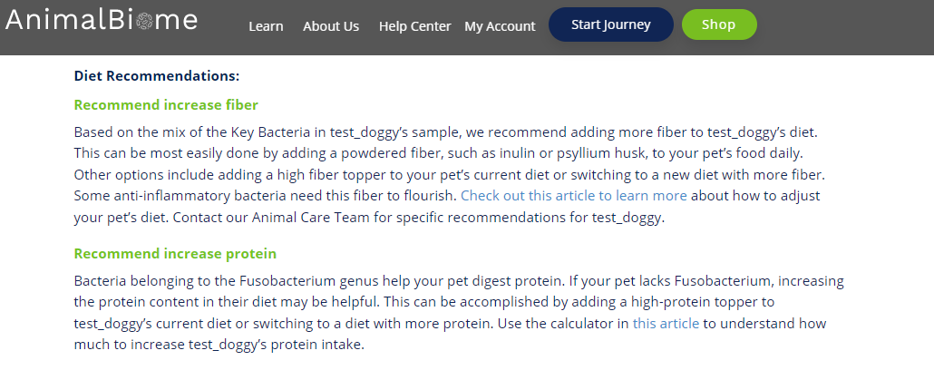

The result : True True True True.

Expected result : Mild to moderate

Acheived result : **passed**.

